Webinar Description for
The Network for Social Work Management
Webinar title
21ST Century Strategies for Outcomes Driven Continuous Quality Improvement
Description
The ability of organizations to focus on a discrete set of priority outcomes in the midst of competing demands on time and resources is a daunting challenge, whether the agency is public or private, large or small. Agencies must also learn to make meaning of vast amounts of data and turn it into evidence that grounds their decision-making and aligns resource allocation. Policy to practice feedback loops and transparent structures are not typically developed, thus leaving executive leadership, middle managers and frontline workers, and continuous quality improvement staff to operate separately from each other as it relates to priorities.
This 60 minute webinar will explore 4 core strategies for building and sustaining a robust outcomes focused continuous quality improvement (CQI) approach: 1) measurable priority outcomes, 2) organization-wide and transparent governance structure, 3) CQI at all organizational levels, and 4) engagement in the cycle of improvement.
Examples of implementing these strategies in the public and private sectors will be shared. Participants will hear the lessons learned and leave with a way to explore the application of these strategies in their own agencies. Participants will also hear about leadership and workforce principles that help build a sustainable foundation for continuous quality improvement efforts.
Learning Objectives:
Participants will gain an understanding of:
- Essential components of an outcomes oriented continuous quality improvement approach
- Methods for aligning agency mission, vision and values with clear priorities and targeted outcomes
- Development of a unified governance structure focused on the achievement of priority outcomes, including how to transition an organization from the current structure to one that supports CQI processes
- Methods for building the CQI capacity of staff at all levels of the agency and the policy to practice linkage

Co-Presenter Information
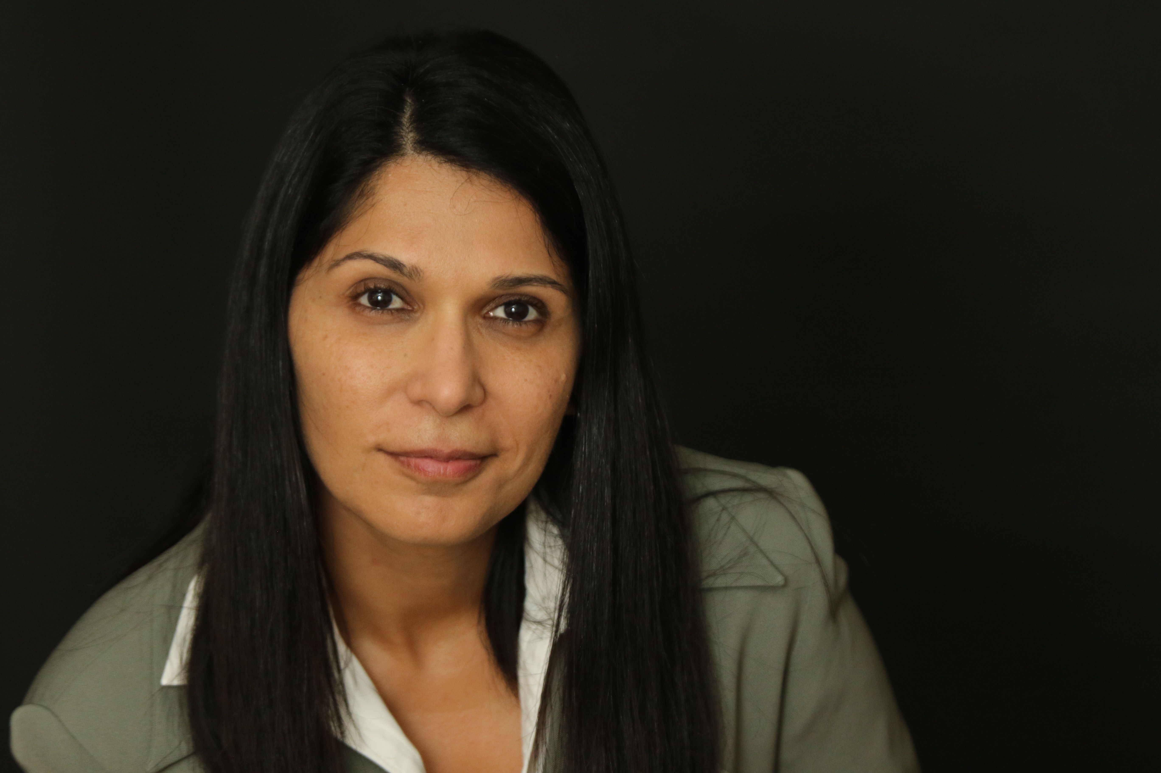
- Name: Khushnuma Cooper, PhD
- Title: CEO
- Agency: Khush Cooper Associates
- City: Los Angeles
- State: California
- Zip: 91367
- Email Address: khush.cooper@ucla.edu
- Phone#: 323-829-3547
Bio:
As a social entrepreneur and specialist in the study and implementation of what’s next for human services, Dr. Cooper uses long-standing relationships with policy-makers, leading practitioners, and consumers to shield and guide California’s organizations, both public and private, through reform initiatives. Starting out as a group home child care worker, she has held the positions of house manager, foster care social worker, non-public school teacher, FFA Director, and Director of Research and Quality at the Gay and Lesbian Adolescent Social Services. Her firm, Khush Cooper and Associates, conducted the first ever LGBTQ Youth Preparedness Scan for LA County which assesses all 11 county departments’ capacity to properly serve LGBTQ children, youth and families in order to prevent future disproportionality of these youth in the child welfare system.
Dr. Cooper serves as an MSW Field Instructor and teaches ‘Being a Leader: An Ontological Phenomenological Approach’ and ‘Public Policy for Children and Youth’ at the Luskin School of Public Affairs at UCLA, where she also received her MSW and PhD in Social Work.

Co-Presenter Information
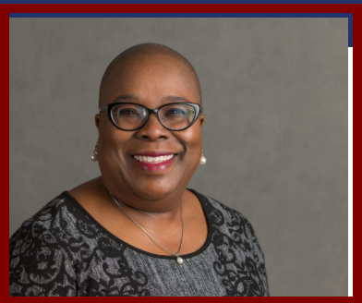
- Name: Yolanda Green-Rogers, MSW
- Title: Senior Policy Analyst
- Agency: Chapin Hall at the University of Chicago
- City: Chicago
- State: Illinois
- Zip: 60637
- Email Address: Yrogers@chapinhall.org
- Phone# 773-256-5218
Bio:
Yolanda Green-Rogers is a Senior Policy Analyst at Chapin Hall at the University of Chicago. Yolanda’s work focuses on supporting public and private human services agencies with the implementation of Continuous Quality Improvement (CQI) practices and protocols that support decision-making and performance monitoring. She conducts assessments of CQI processes, designs and delivers training and coaching to increase staff capacity to implement CQI principles and techniques, and makes recommendations to organizational leaders on using the CQI process to achieve priority organizational outcomes.
Yolanda is a Quality Assurance Specialist and reviewer for federal Child and Family Services Reviews conducted by the U.S. Department of Health and Human Services to evaluate state child welfare systems across the country. Yolanda also teaches a course on quality monitoring and improvement in the social services for the MSW program at the University of Chicago’s School of Social Service Administration. Yolanda holds a MSW degree from the University of Illinois-Chicago.

