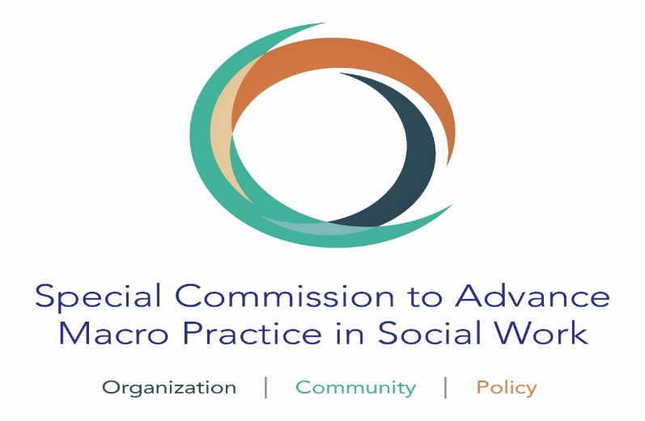
December 3, 2018
Dear Colleagues:
We are both pleased and privileged to announce that as the Co-chairs of the Special Commission to Advance Macro Practice in Social Work, we have just signed a contract with Oxford and NASW Presses to co-edit the first-ever Encyclopedia of Macro Social Work! This honor is perfect in many ways.
First, this invitation speaks volumes about the increasing recognition of the work and accomplishments of the now 5 years old Special Commission.

Additionally, launching this initiative is well- timed with the Macro Specialization Curricular Guide just completed with its debut at the APM of CSWE last month. Our new logo above illustrates that “macro” encompasses three components: Organization, Community, and Policy (insert link). The Macro Guide has been designed to facilitate the continued development of macro practice in our masters- level curricula and within our field agencies as well as for use by BSW programs as they balance micro and macro content. And next is this big venture.

The Encyclopedia of Macro Social Work (EOMSW) will be its own two or three volume print edition separate from the on-line/digital Encyclopedia of Social Work (EOSW). Articles written or revised for the EOMSW will also be published in the larger EOSW.

Our next step as Co- Editors is to identify six Associate Editors with the experience, passion, time, and energy to bring this pioneering tome to publication by the end of 2019. Because there are so many qualified individuals with such capabilities, we are immediately reaching out to you for your assistance. As we hope will be reflected in the Encyclopedia itself, our goal is to have an Editorial Team that reflects even part of the breadth of diversity of ‘people and place’ that enriches our profession as a whole. While ambitious, it is our intention to have on this team colleagues from programs small and large, public and private, stand alone and part of a larger college, who collectively represent multiple perspectives of macro education, research and practice, are from different regions of our country, and who are various stages of their career.

We ask you to nominate yourself or others you believe would join us in making a substantial contribution to this effort. Many thanks for taking the time to think about this and get back to us!
These are the procedures we ask that you follow. Before you identify or nominate someone, please ascertain their willingness and ability to serve in this capacity throughout the next year. Then complete (or have them complete) the form found here. Do not attach a CV or Resume at this time.

- Name, title/position/institution/best contact info—cell phone and email address
- The name and contact information of one colleague who best knows your competencies relevant to this task
- In no more than 250 words, please answer the following questions: “Why do you want to be considered as an Associate Editor?” Which of your qualifications and background do you consider pertinent to this position? In which area(s) of macro do you have expertise? Do you have the time commitment which would allow you to devote yourself to the EOMSW this coming year?

- No more than 250 words describing of your major accomplishments. This could include:
- identification of editorial board experience
- description of your major scholarship
- leadership positions in any relevant professional organization.
Among the duties we anticipate as a team:
- Deciding on the content/titles to be included. This will consist of reviewing current entries in the EOSW pertinent to “Macro” and identifying new topics and areas for inclusion.
- Helping to identify writers of revised, updated and new content
- Reviewing and commenting on approximately twenty submitted entries in a timely fashion
Associate Editors will sign separate Agreements with Oxford University Press and will receive $1,000 Compensation. This amount is to be considered as an honorarium in recognition of the anticipated contribution each Associate Editor will make to this important and timely product.
We look forward to working and sharing with you the results of the EOMSW.
Best regards,
Darlyne Bailey and Terry Mizrahi, Co-Editors

